OIL CONDITION MONITORING REPORT SLNS SHAKTHI

GEAR BOX PARTICULARS (Information provided by the customer)
 | Stbd Gear Box
Make : | SHICHUAN
Model : | GWC 3235
Sr.No’s: | N/A
Date sampling : 13.02.2019 | 12 May 25
Sampling point : | Lube Oil Sump
Sampling Method : | Extraction
Type of Lubricant : | Caltex Lanka Super 15 W 40
System Capacity : | 45 Ltrs

RUNNING HRS DETAILS(Information provided by the customer)
 | Stbd Gear Box
Sample ID | M010154
Oil Running Hours | 959.35
Total Running Hours of the Machinery | 37647.55

ANALYSIS RESULTS

Description | METHOD | Fresh Oil  (As per OEM data sheet) | Uncertainty  (K=2) | Stbd Gear Box
 |  |  |  | S/I- M010154
Viscosity @ 40ºC (cSt) | ASTM D 445 | 109.4 | 0.006 | 84.62
Viscosity @ 100ºC (cSt) | ASTM D 445 | 14.4 | 0.005 | 11.65
Viscosity Index | ASTM D 2270 | 134 | N/A | 128.99
Water contain % | ASTM D 95 | <0.2 | 0.082 | <0.1

Elemental Concentration as per ASTM D5185 (ppm)

Element | Maximum Permissible Limit | Fresh Oil Sample | Uncertainty  (K=2) | Stbd Gear Box
 |  |  |  | S/I- M010154
Fe | 300 | < 1.000 | 0.15 | 14.591
Cr | 15 | < 1.000 | 0.18 | < 1.000
Si | 50 | < 1.000 | 0.17 | < 1.000
Al | 30 | < 1.000 | 0.28 | 1.185
Pb | 1500 | < 1.000 | 0.13 | 4.788
Cu | 250 | < 1.000 | 0.17 | 4.214
Sn | 50 | < 1.000 | 0.20 | < 1.000
Ni | 30 | < 1.000 | 0.08 | < 1.000

TREND ANALYSIS WITH PREVIOUS REPORTS

 |  | Fresh oil sample | Stbd Gear Box
 |  | Fresh oil sample | S/I-M000389 | S/I-M000926 | S/I-M002463 | S/I-M004167 | S/I-M006104 | S/I-M007847 | S/I-M008005 | Fresh oil sample | S/I-M010154
Oil Running Hrs |  | - | 995.40 | 832.50 | 1030.05 | 867.35 | 283.20 | 500.00 | 531.45 | - | 959.35
T/R/H of Machinery |  | - | 31595.25 | 32428.15 | 33269.55 | 35740.05 | 36156.10 | 36656.10 | 36688.20 | - | 37647.55
Basic Properties
Viscosity @ 40ºC (cSt) |  | 132.31 | N/C | 134.81 | 138.18 | 133.59 | 139.35 | 129.71 | 132.88 | 109.4 | 84.62
Viscosity @ 100ºC (cSt) |  | 14.4 | N/C | 14.16 | 14.30 | 14.23 | 14.81 | 14.07 | 13.60 | 14.4 | 11.65
Viscosity Index |  | 97 | N/C | 102.54 | 101.24 | 104.56 | 106.46 | 106.24 | 97.45 | 134 | 128.99
Water contain % |  | <0.2 | N/C | N/C | N/C | N/C | N/C | N/C | N/C | <0.2 | <0.1
Elemental Concentration as per ASTM D5185 (ppm)
Element | Maximum Permissible Limit
Fe | 300 |  | 31.764 | 161.723 | 71.401 | 128.269 | 116.947 | 19.390 | 24.846 | < 1.000 | 14.591
Cr | 15 |  | < 1.000 | < 1.000 | < 1.000 | < 1.000 | < 1.000 | < 1.000 | < 1.000 | < 1.000 | < 1.000
Si | 50 |  | 3.844 | 6.724 | 7.926 | 3.414 | 9.536 | < 1.000 | < 1.000 | < 1.000 | < 1.000
Al | 30 |  | < 1.000 | < 1.000 | < 1.000 | < 1.000 | < 1.000 | < 1.000 | < 1.000 | < 1.000 | 1.185
Pb | 1500 |  | 5.801 | 13.258 | 7.984 | 3.432 | 20.619 | 5.855 | 10.033 | < 1.000 | 4.788
Cu | 250 |  | 4.954 | 14.061 | 12.373 | 3.948 | 34.856 | 6.879 | 12.181 | < 1.000 | 4.214
Sn | 50 |  | < 1.000 | < 1.000 | < 1.000 | < 1.000 | < 1.000 | < 1.000 | < 1.000 | < 1.000 | < 1.000
Ni | 30 |  | < 1.000 | < 1.000 | < 1.000 | < 1.000 | N/A | < 1.000 | < 1.000 | < 1.000 | < 1.000

Wear Metals

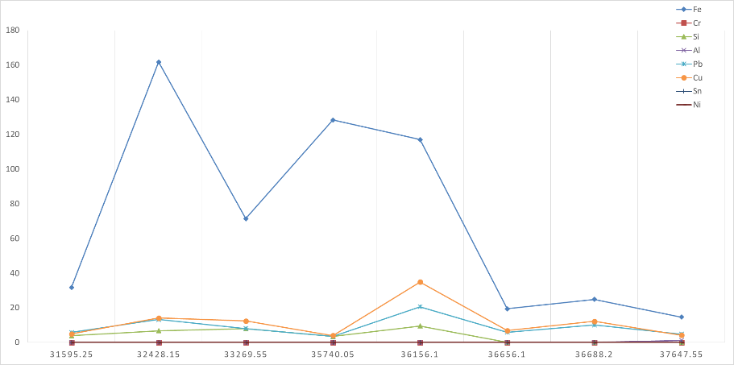

(ppm)

Total Running Hrs

Viscosity
Total Running Hrs
40⁰C 100⁰C
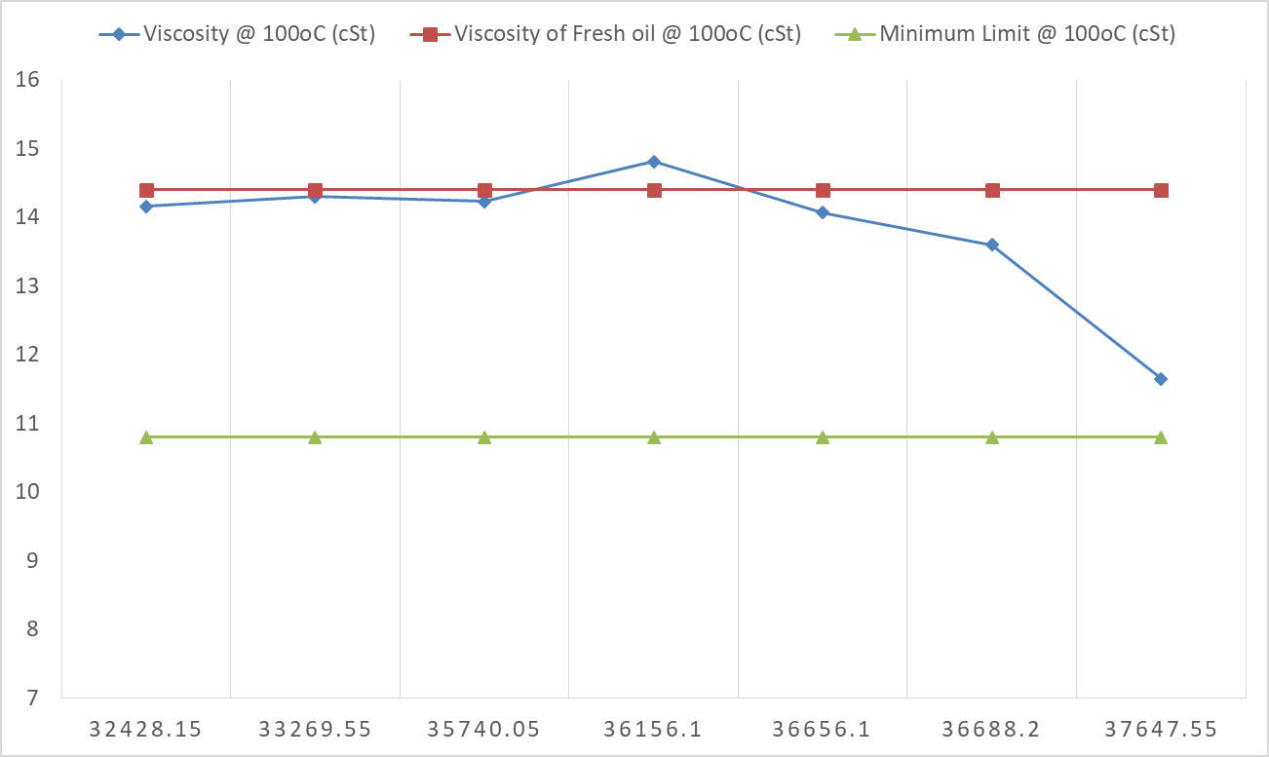
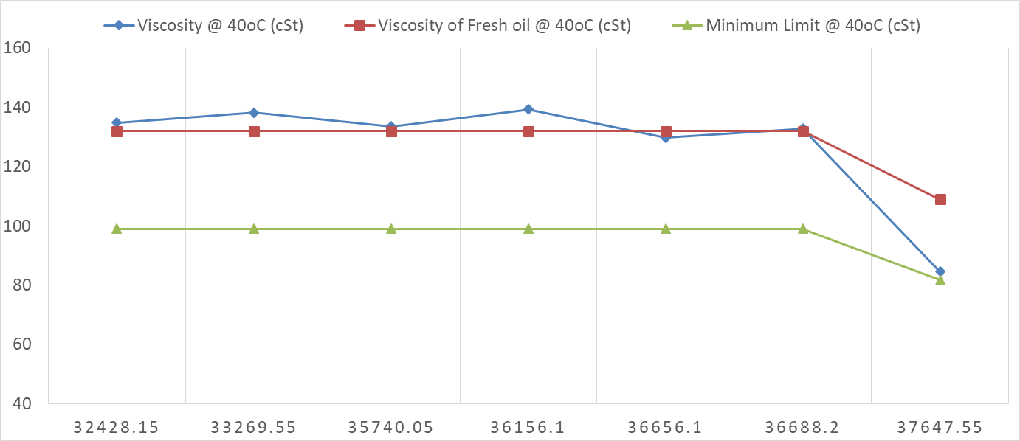

(cSt)
(cSt)

Total Running Hrs
Total Running Hrs
Total Running Hrs

